Balkan Olympiad in Informatics 2007  Chisinau, Moldova |  | Country
Task: Stairway |  | Day 2

The stairways of Saharna

Saharna is a beautiful, sceneric place in Moldova where, among all the caves and waterfalls, one can find a variety of stones of different forms and sizes. In the Middle Ages, these stones were used to construct the stairways of the fortresses. As a rule, each step of the stairway was formed of just one stone.
The stones are heavy and for this reason their positions are fixed along a string, that is the stones are in a given order. The craftsmen know the heights of the stones, hence they have a sequence of integers 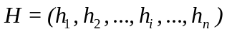, where h_{i} represents the height of the i^{th} stone.
To build a stairway, the craftsmen went along the string and selected consecutively a stone for each step of the stairway in construction. Obviously, a stone can be selected only when its height is not lower than the height of the previously selected stone.
As an example, if H = (1; 3; 4; 2; 3; 4; 1; 2; 2; 3; 3; 2), to build a stairway one can select the underlined stones in the sequence below:
H = ( 1; 3; 4; 2; 3; 4; 1; 2; 2; 3; 3; 2).
Since bigger is necessarily better, to build a better castle the craftsmen had to use as many stones as possible for the construction of the stairways.
We denote by 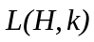 the maximal number of stones that can be used to build k stairways, each having at least one step.
For the above example, it is not hard to see that 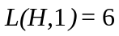, that is, the underlined stones represent an optimal stairway.
Similarly, one can check that 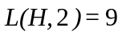, as can be seen from the example below, where the stones for the first stairway are underlined with one line ( ) and the stones of the second stairway are underlined with a double line ( ) .
H = ( 1; 3; 4; 2; 3; 4; 1; 2; 2; 3; 3; 2).
It is seen that for 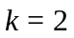, for the first stairway the craftsmen use 6 stones, and for the second – 3.
If one wants to build 3 stairways, the maximal number of stones that can be used is seen in the example below:
H = ( 1; 3; 4; 2; 3; 4; 1; 2; 2; 3; 3; 2 ),
The bold underlinement represents a 3rd stairway, while the other lines have the same significance as before. Hence, 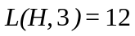. One sees that for 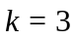, for the first stairway 5 stones were used, for the second 4 stones, and for the third 3 stones. Please remark that the first and second stairways chosen for 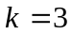 differ from the stairways chosen in the previous cases (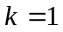 and 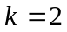).
It is also clear that by taking k to be consecutively 1, 2, 3, and so on, at some point, for some number q, 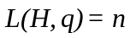, where n is the total number of stones.
Your task is to help the medieval craftsmen and write a program which, given the sequence of heights H, computes the maximal number of stones that can be used in k stairways - , where 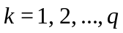.

Input data. The text file stairway.in contains on the first line the positive integer n. The second line of the file contains the positive integers h₁, h₂, ..., h_{i}, ..., h_{n}, separated by blanks.

Output data. The text file stairway.out will contain on each of the q lines a positive integer. The k^{th} line of the file will contain the number , 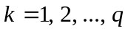.

Example.

stairway.in |  | stairway.out
12  1 3 4 2 3 4 1 2 2 3 3 2 |  | 6  9  12

Restrictions. 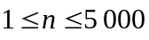; 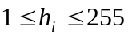 , 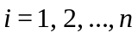. CPU time will not exceed 0.2 seconds. The program will use at most 64 MB of memory. The source file will be named stairway.pas, stairway.c or stairway.cpp.

